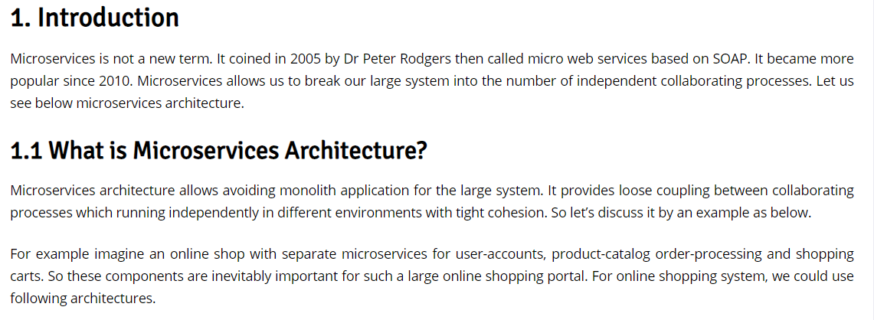

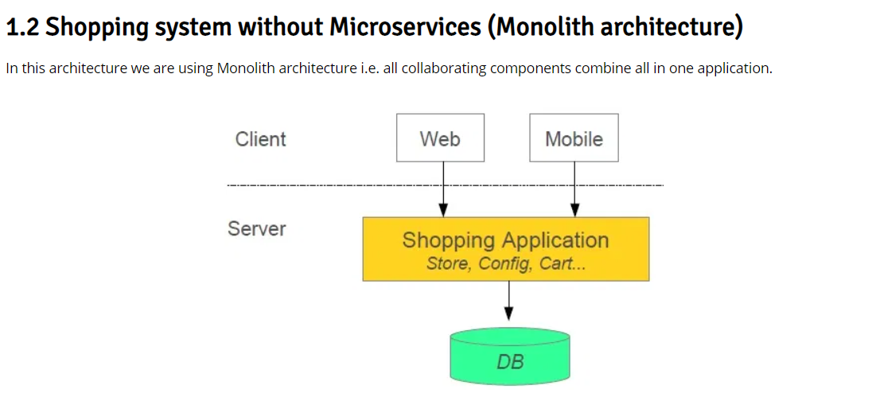

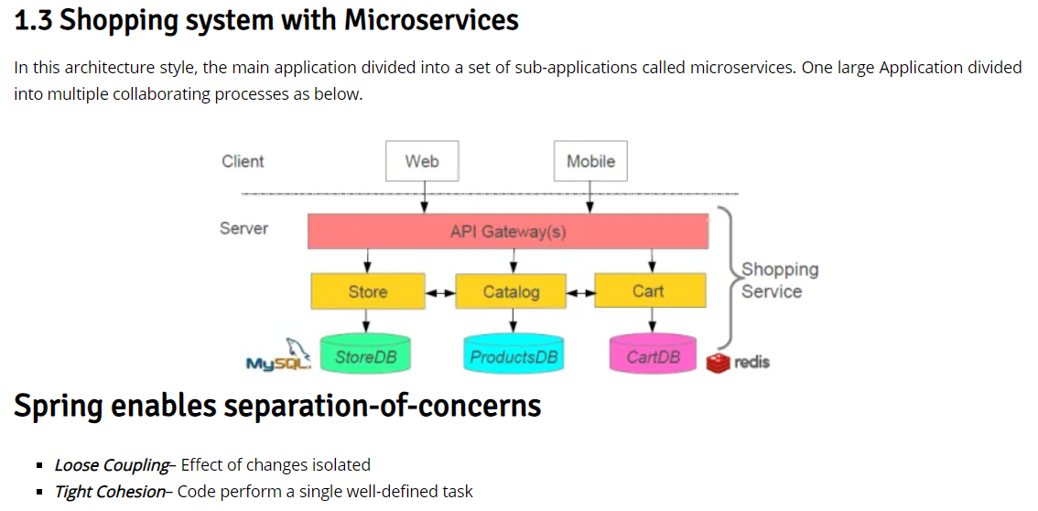

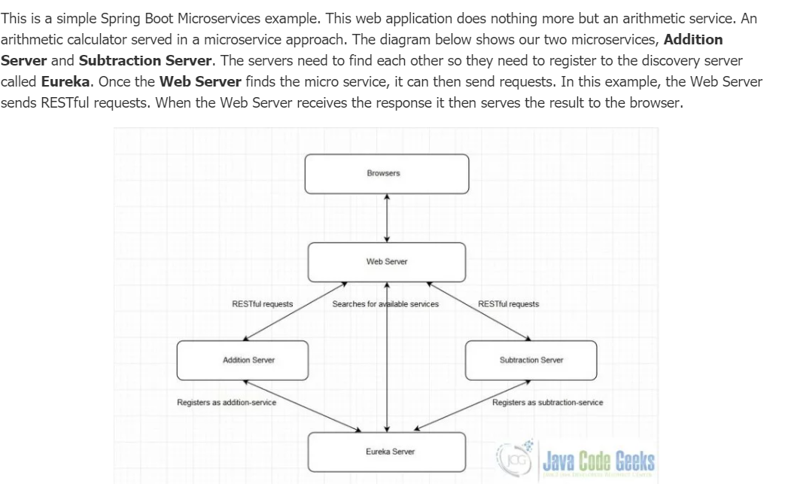

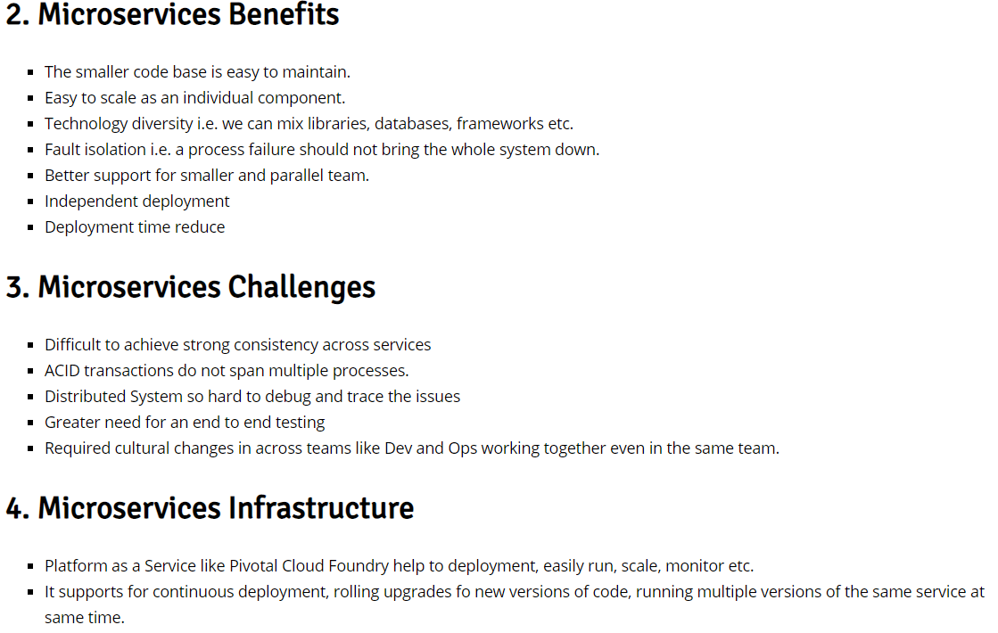

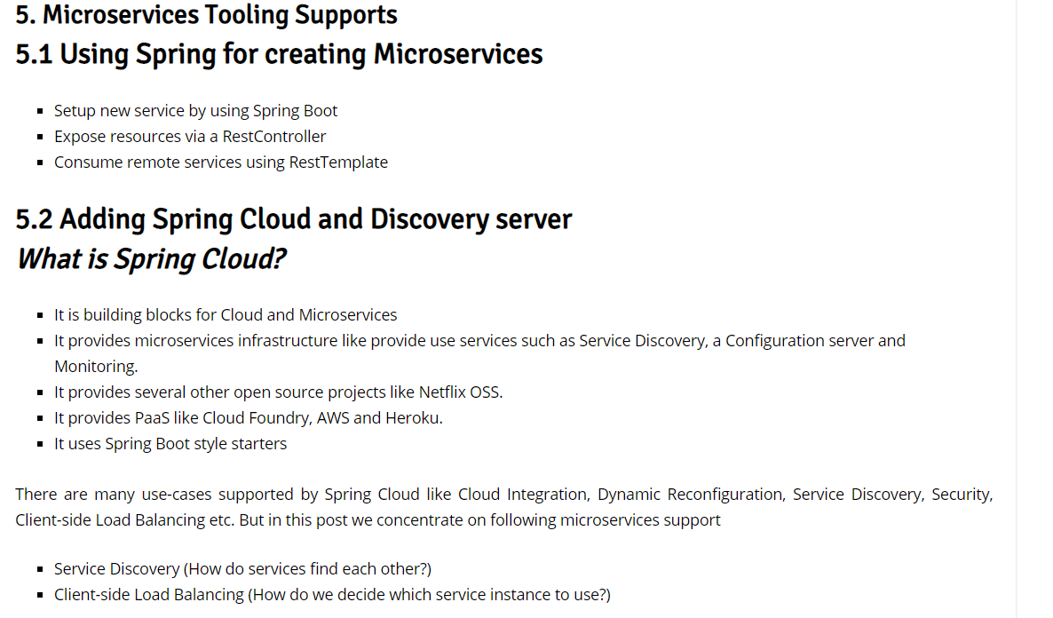

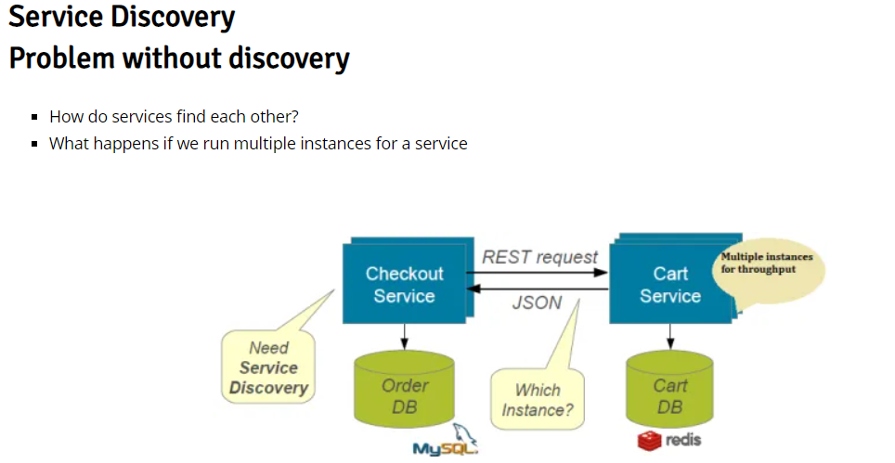

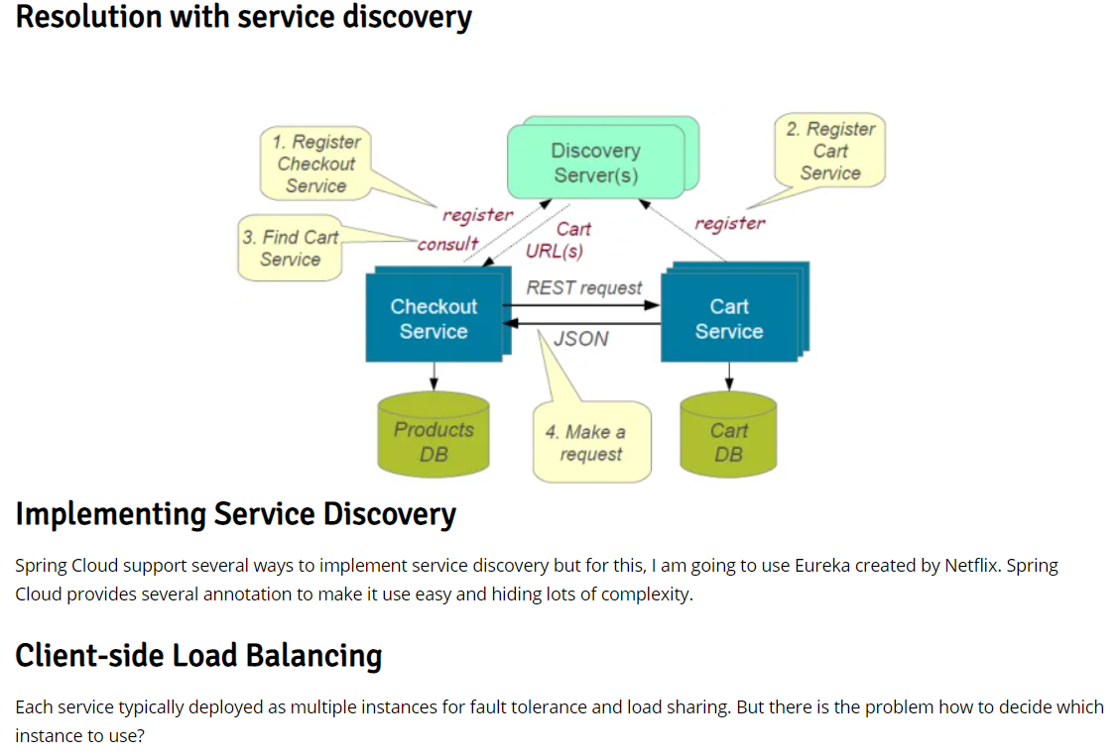

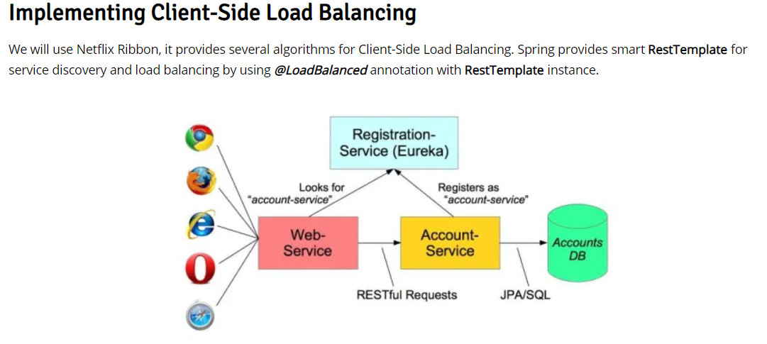

**Spring Boot Microservices: Building a Microservices Application Using Spring Boot**

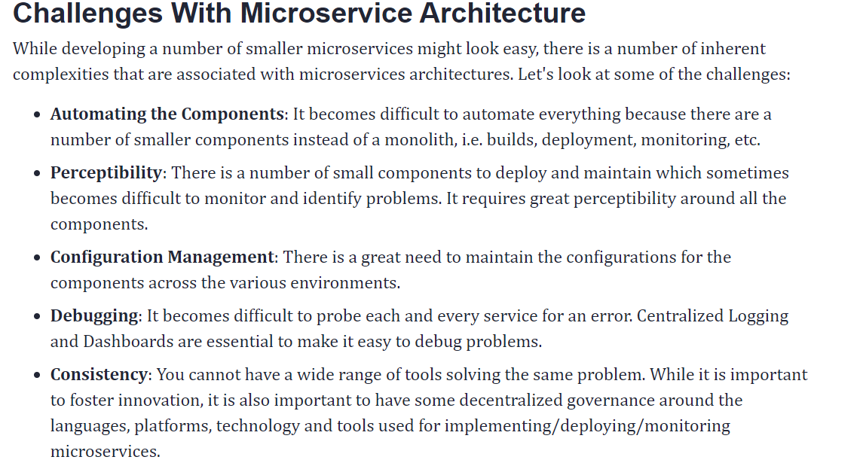

## **Building Architecture for Top Sports Brands With Spring Boot**

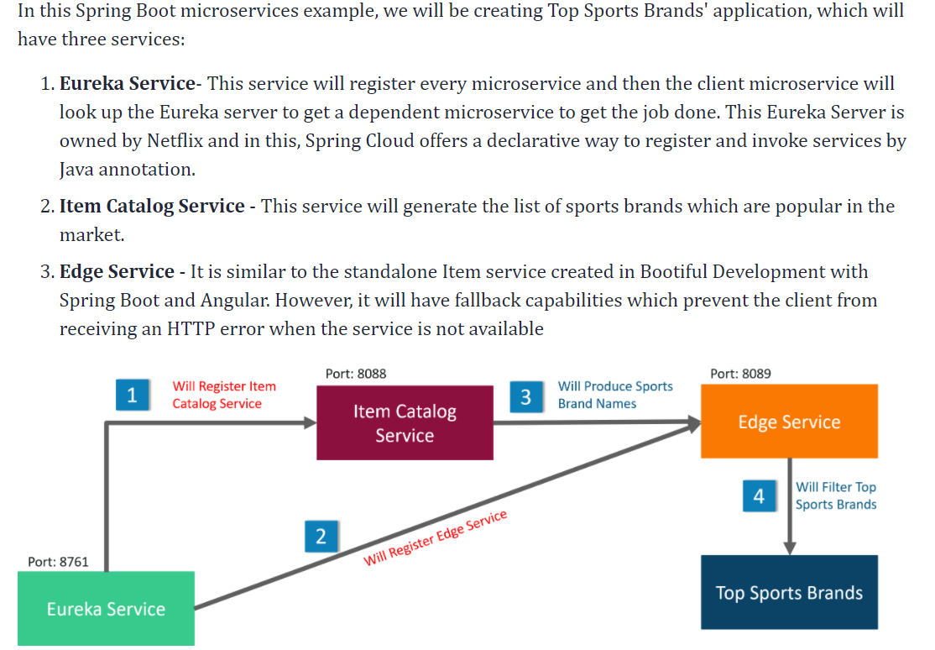

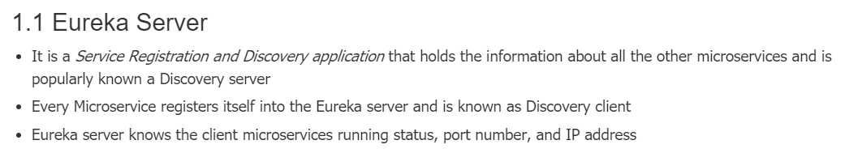

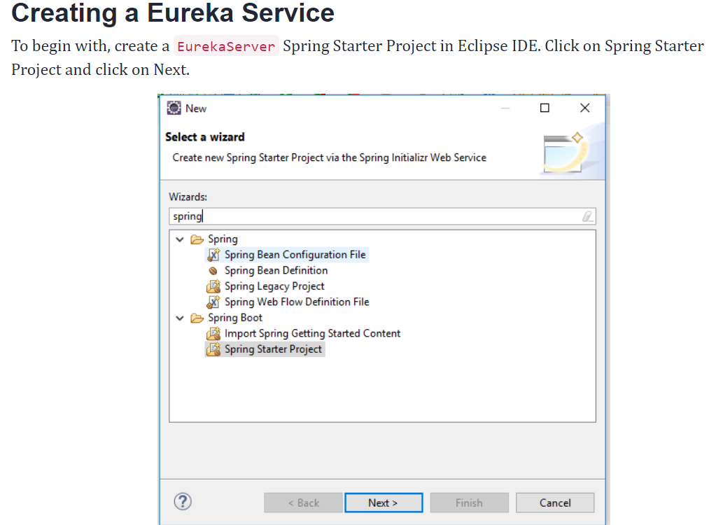

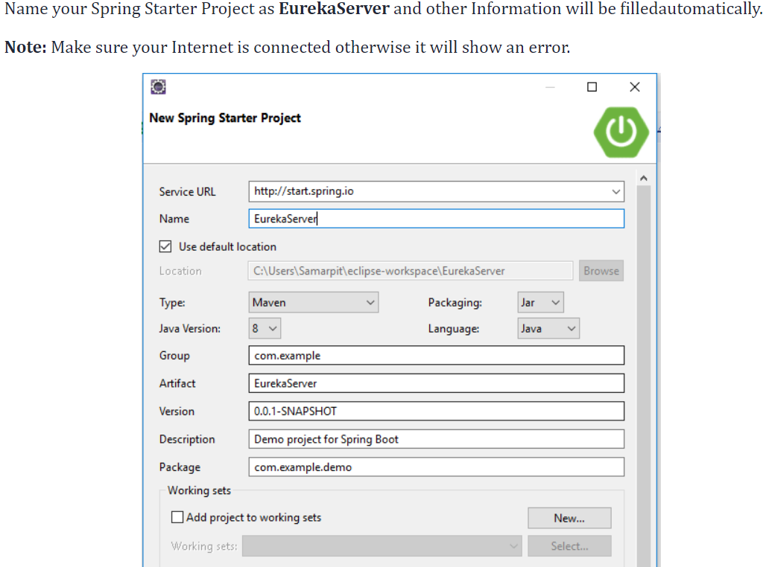

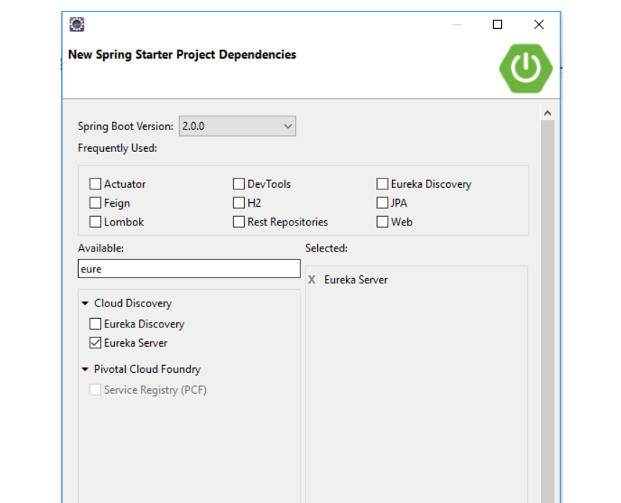

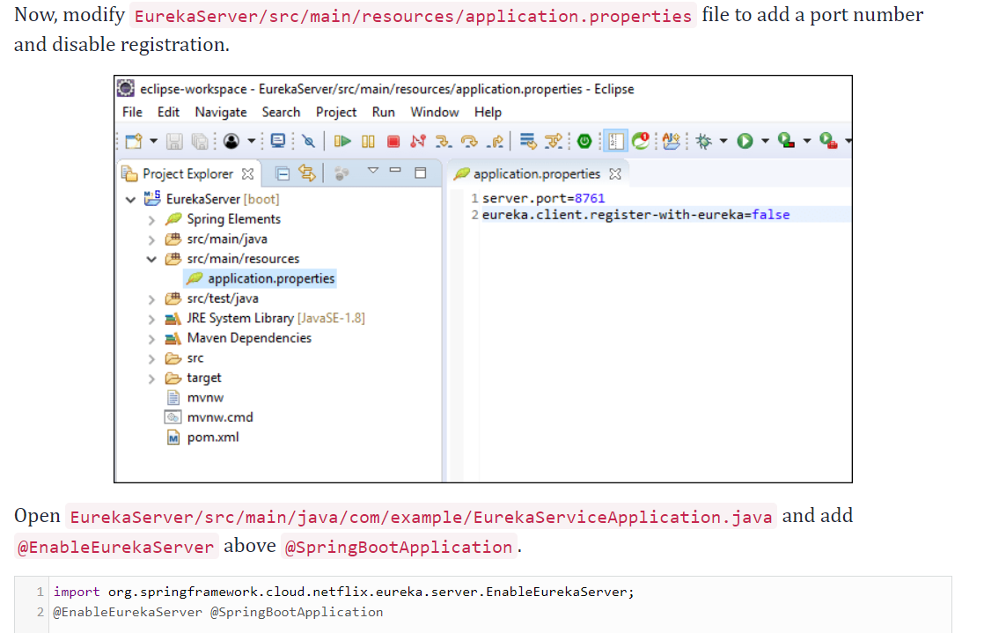

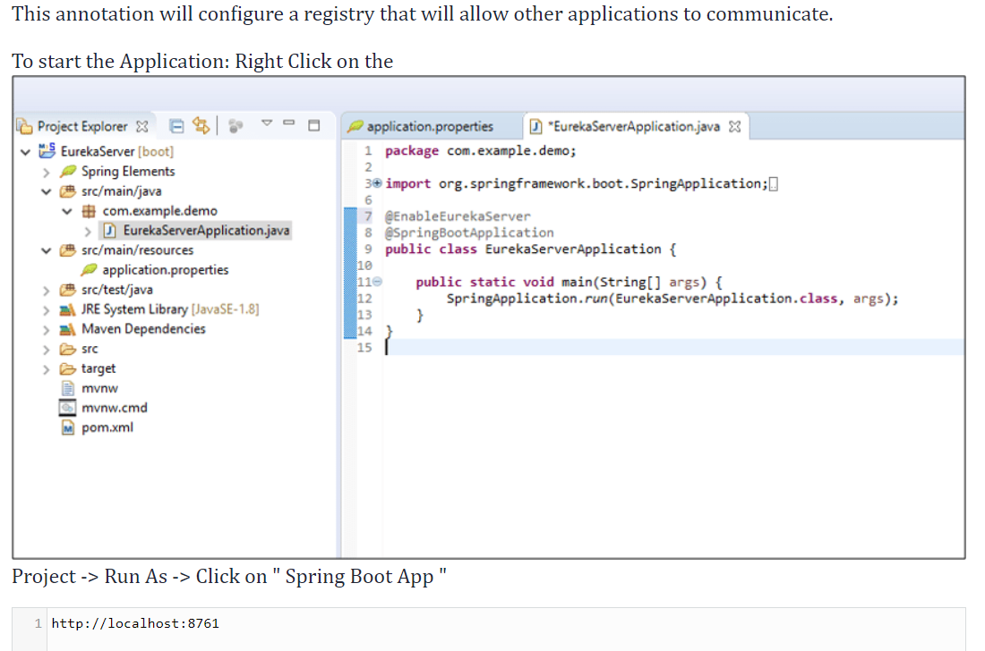

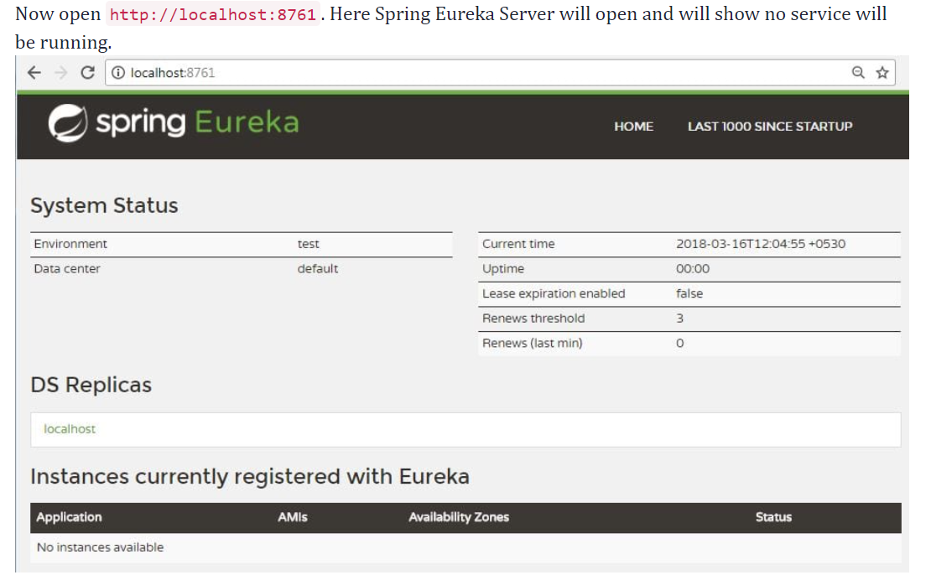  
  
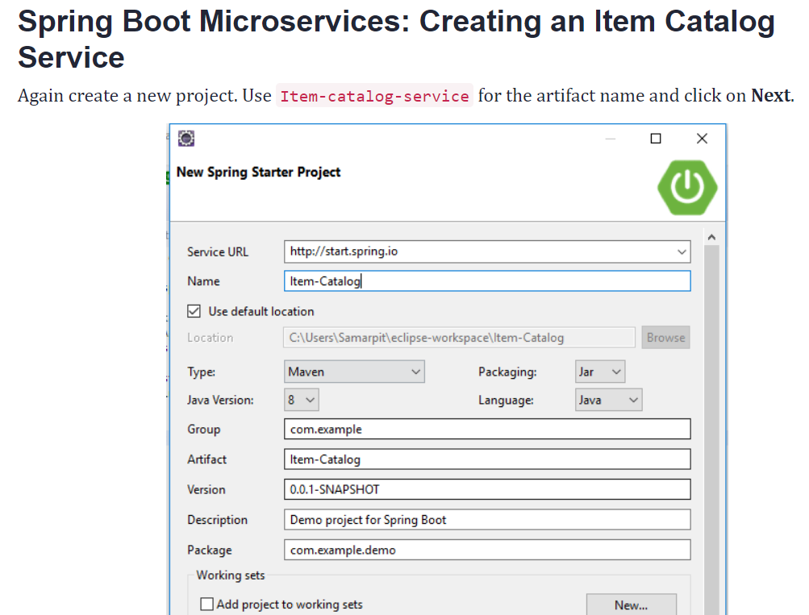

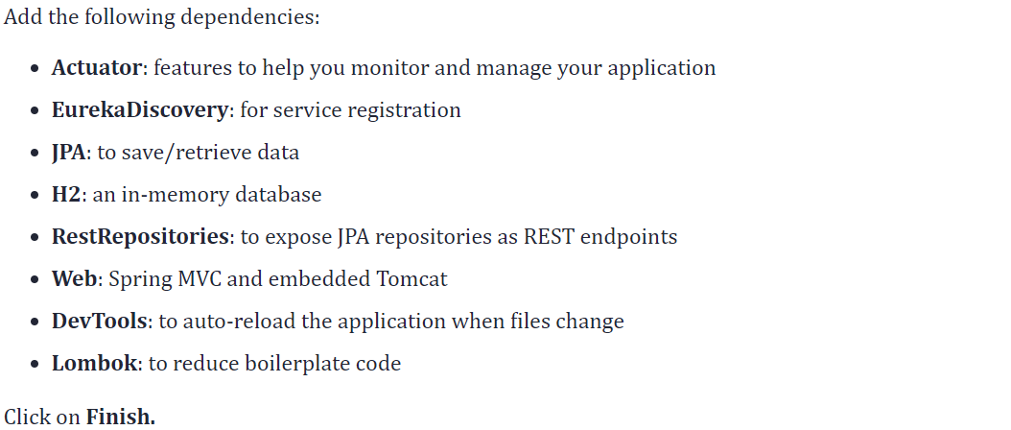  
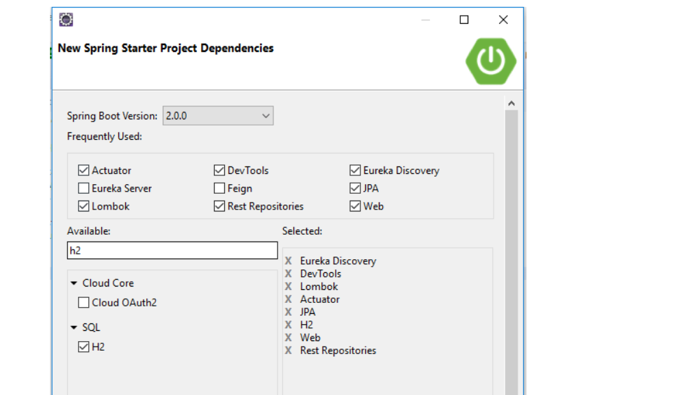  
Add an application name in Item-Catalog/src/main/resources/application.properties file to display in the Eureka service, and set the port to 8088.  
  
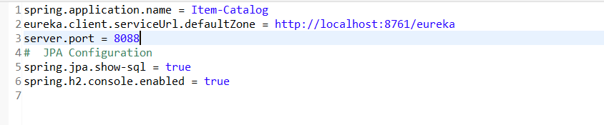

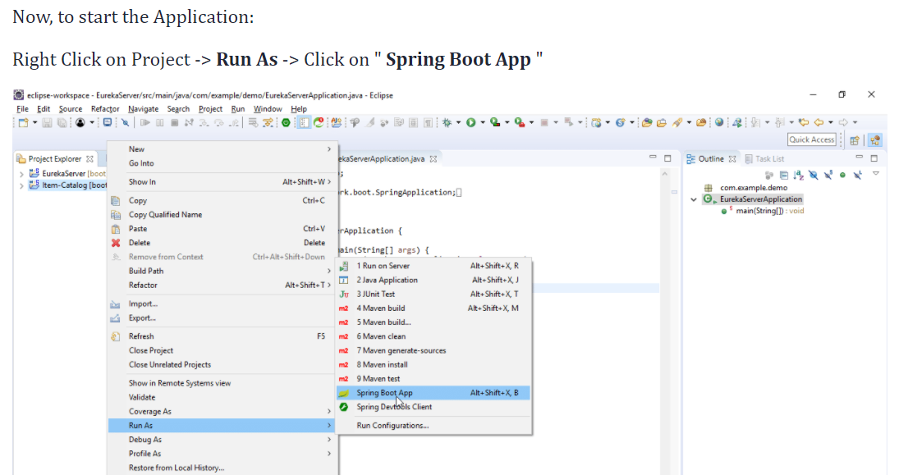  
Note: In case of error try this step: Right Click on the **Project** -> **Run As** -> Click on "**Maven Build.**"  
Now open http://localhost:8761. Here you will see Item Catalog service will be running.  
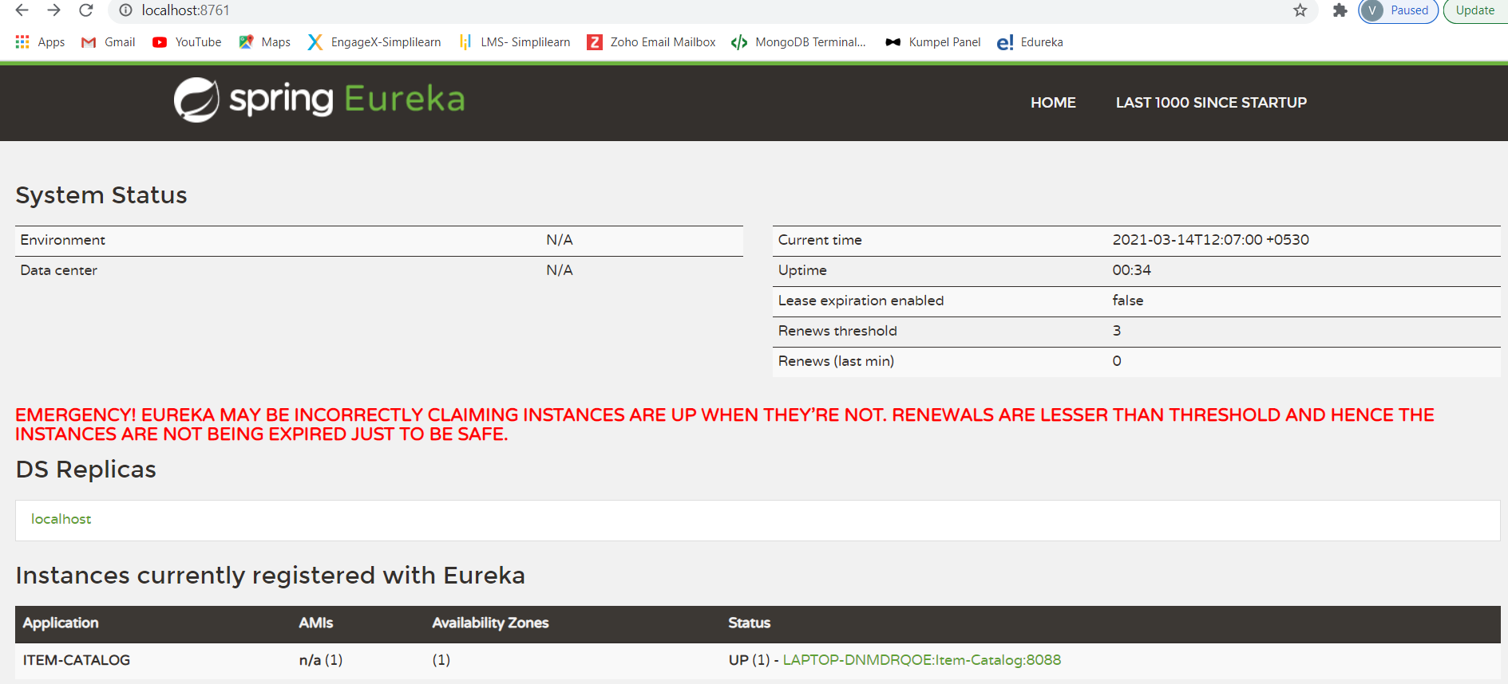

Example in Eclipse:

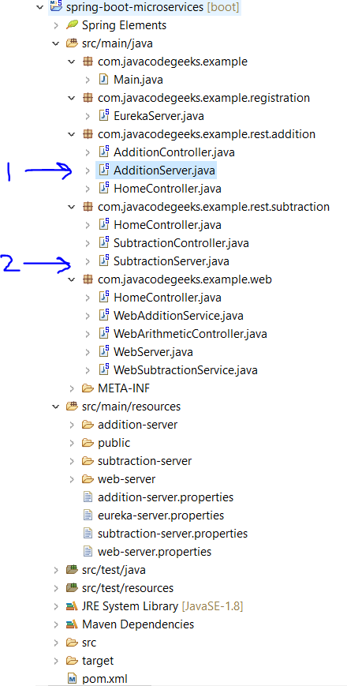  
**To run the application: (1)**   
1. Maven clean 🡪 Maven Install  
2. Right click on “AddtionServer.java” and click Run as “Java Application”  
3. Open URL 🡪 <http://localhost:2222/>   
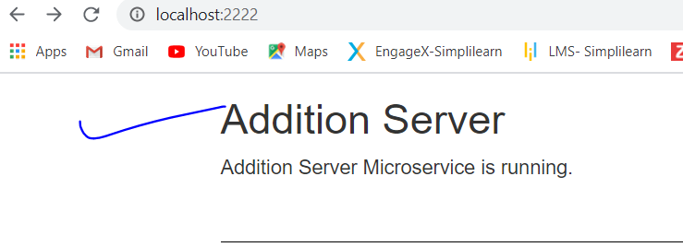

4. type now 🡪 <http://localhost:2222/add>   
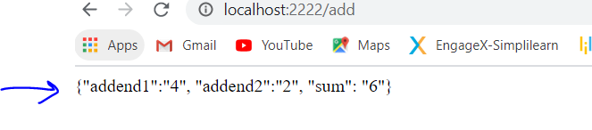

**To run the application: (2)**   
1. Maven clean 🡪 Maven Install  
2. Right click on “SubtractionServer.java” and click Run as “Java Application”  
3. Open URL 🡪 <http://localhost:3333/>   
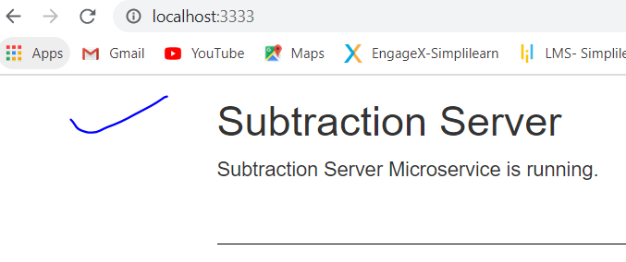  
4. type now 🡪 <http://localhost:3333/subtract>   
